

Plymouth Nursery Schools Federation 5 Top Tips for Communication
1 | Let the child lead the play  Stop your agenda and watch and listen to what the child is doing and saying.
2 | Come down to the child’s level  Join the child’s play and ensure that they can see your face when you are talking. | 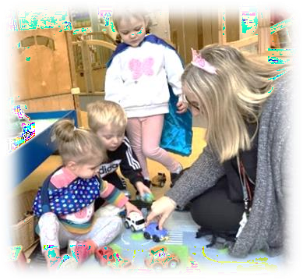  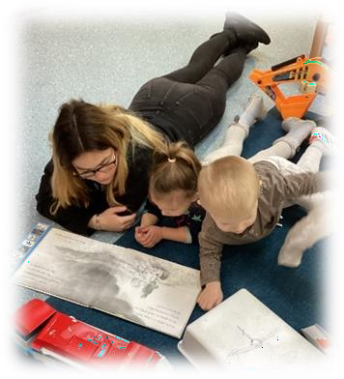  PHOTO
3 | Match your language to that of the child  Repeat back what the child says and, where appropriate, add in one or two new words e.g. if the child says ‘car’, you could reply ‘big car’. | 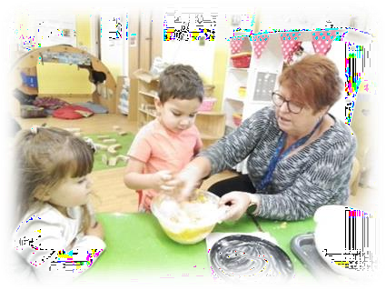
4 | Leave time for the child to respond to comments or questions  Children can take up to 10 seconds to process what has been said and to think of a response. | 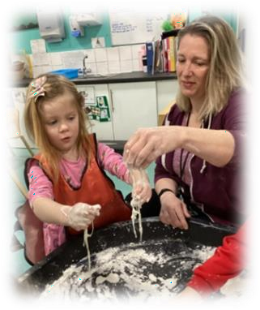
5 | Use more comments than questions  Remember the hand rule (4 comments and 1 question).  Try to use open questions like, ‘I wonder what will happen if…’ | 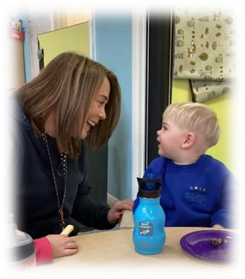  PHOTO

