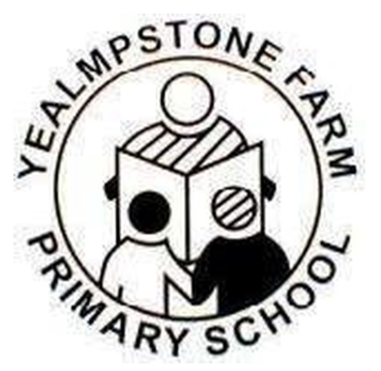
Yealmpstone Farm Primary School 2026.27
PE Curriculum Map

F | Topic: All about Me  Locomotion: Moving my body safely. | Topic: Celebrations  Dance: Celebratory dances | Topic: People Who Help Us  Ball Skills: Help and Rescue | Topic: Traditional Tales  Dance: Storytelling | Topic: Transport  Athletics: What my body can do! | Topic: Animals  Gymnastics: On a Safari
Value | Self-Belief | Determination | Respect | Passion | Honesty | Teamwork
Y1 | Locomotion: running and jumping | Health and wellbeing: the effects of exercise | Ball skills: sending, receiving and dribbling | Gymnastics: individual movements and balances | Outdoor adventurous activities: working with others | Dance: my moves, my journeys
Y1 | Locomotion: running and jumping | Dance: my moves, my brilliant body | Ball skills: sending, receiving and dribbling | Gymnastics: individual movements and balances | Outdoor adventurous activities: working with others | Ball skills: pushing and striking
Value | Self-Belief | Determination | Respect | Passion | Honesty | Teamwork
Y2 | Locomotion: running, jumping and dodging | Health and wellbeing: agility, balance and coordination | Ball skills: passing, dribbling and scoring | Gymnastics: linking movements and balances | Outdoor adventurous activities: team building | Ball skills: hitting and striking
Y2 | Locomotion: running, jumping and dodging | Dance: my world, weather | Ball skills: passing, dribbling and scoring | Gymnastics: linking movements and balances | Outdoor adventurous activities: team building | Dance: my world, how we dance
Value | Self-Belief | Determination | Respect | Passion | Honesty | Teamwork
Y3 | Outdoor adventurous activities: team challenges  (Cross Curriculum Scheme) | Dance: my word links to language | Invasion games: principles of attack and defence in netball | Health and wellbeing: mindfulness and meditative balances | Gymnastics: movements, balances and sequence composition | Athletics: athletic challenges
Y3 | Invasion games: principles of attack and defence through ball games | Dance: my word links to language | Net and wall games: tactics and strategies to overcome an opponent |  | Gymnastics: movements, balances and sequence composition | Striking and fielding games: fielding vs batting
Value | Self-Belief | Determination | Respect | Passion | Honesty | Teamwork
Y4 | Outdoor adventurous activities: solving problems  (Cross Curriculum Scheme) | Dance: traditional dances of the British Isles | Invasion games: maintaining possession and stopping an attack through basketball | Gymnastics: symmetry and asymmetry | Athletics: athletic challenges developed | Striking and fielding games: tactics and strategies through racing rounders
Y4 | Invasion games: maintaining possession and stopping an attack in ball games | Dance: traditional dances of the British Isles | Swimming Life Centre | Gymnastics: symmetry and asymmetry | Net and wall games: tactics to overcome an opponent through pickleball | Health and wellbeing: mindfulness, meditative balances and relaxation techniques
Value | Self-Belief | Determination | Respect | Passion | Honesty | Teamwork
Y5 | Outdoor adventurous activities: orienteering  (Cross Curriculum Scheme) | Invasion games: shooting, scoring and denying space through hockey | Striking and fielding games: striking and fielding skills through cricket |  | Dance: your tag, everyday art | Health and wellbeing: stamina, strength and flexibility
Y5 | Invasion games: shooting, scoring and denying space in ball games | Net and wall games: tactics to overcome an opponent through tennis | Gymnastics: counter balance and counter tension | Gymnastics: flight | Dance: your tag, everyday art | Athletics: enhanced athletic challenges
Value | Self-Belief | Determination | Respect | Passion | Honesty | Teamwork
Y6 | Outdoor adventurous activities: leadership | Invasion games: scenarios, tactics and power play through tag rugby | Striking and fielding games: striking and fielding tactics through rounders | Dance: the power of unity | Athletics: athletic challenges refined | OAA/Forest School
Y6 | Invasion games: scenarios, tactics and power play in ball games | Net and wall games: tactics to overcome an opponent through badminton | Gymnastics: matching and mirroring | Health and wellbeing: stamina, strength and flexibility refined | Parkour: developing confidence and creative movement | OAA/Forest School
Value | Self-Belief | Determination | Respect | Passion | Honesty | Teamwork

