PE Progression of Skills
Dance   | EYFS | Year 1 | Year 2 | Year 3 | Year 4 | Year 5 | Year 6 | KS3
Performance   | I can copy steps and actions with some control and co-ordination. | I can copy and explore basic body patterns and movements. | I can perform patterns and movements with control and co-ordination. | I can improvise purposefully on my own using different length movements. | I can improvise freely on my own and in a group linking different movements and repeating patterns | I can demonstrate precision, control and fluency in response to a stimuli. | I can create and perform dance motifs accurately and consistently | perform dances using advanced dance techniques within a range of dance styles and forms
Composition   | I can link individual and whole body movements together. | I can remember and choose simple dance steps and perform them in a controlled manner. | I can respond imaginatively to a variety of stimuli. | I can translate ideas from a variety of stimuli into movement. | I can vary the dynamics depending on the stimuli suitably | I can vary dynamics and develop actions with a partner or as part of a group. | I can use compositional skills to demonstrate ideas and translate into performance.
Evaluation  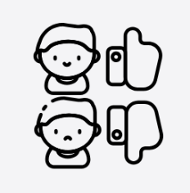 | `I can watch others work and choose actions. | I can identify movements and patterns others have chosen | I can make simple improvements to my performance | I can develop a dance sequence towards a stimulus.  I can make suggestions to others comparing their sequence to a stimulus | I can compare develop and adapt movement motifs to create longer dances.  I can use dance vocabulary to compare and improve my work and others. | I can adapt and link phrases and motifs to create a wide performance. | I can suggest ways to improve quality of a performance showing sound knowledge and understanding which affects the rhythm and spatial awareness in my dance | analyse their performances compared to previous ones and demonstrate improvement to achieve their personal best
Body awareness | I can use the space available to me in an activity .  I can identify when my body is being active and still. | I can safely perform teacher led warm-ups accurately. | I understand the need for warm up and cool down. | I can understand how to work safely.  I recognise changes in my body during PE.  I can give reasons why Dance is good for health. | I can explain safety concerns in different environments. | I can modify my performance based on space and resources available.  I can organise myself to warm up safely. | I am aware of my body’s ability and limitations.  I can lead others safely in warm ups using exercises which are linked to Dance.
Gymnastics  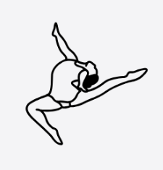 | EYFS | Year 1 | Year 2 | Year 3 | Year 4 | Year 5 | Year 6 | KS3
Performance | I can copy individual and whole body movements with some control and co-ordination. | I can sequence basic gymnastics actions with some control and co-ordination. | I can sequence a variety of basic gymnastics actions with control and co-ordination | I can sequence a variety of basic gymnastics actions with control and co-ordination, starting to use some basic apparatus. | I can combine and perform gymnastics actions into a short routine with control, coordination and precision. | I can create and perform a complex sequence of gymnastics in a routine. | I can create and perform a complex sequence of gymnastics in a routine, carefully considering fluidity of my actions. | develop their technique and improve their performance in other competitive sports [for example, athletics and gymnastics]
Composition | I can link individual and whole body movements together. | I can select and link basic gymnastic actions together. | I can select and link basic gymnastics actions into fluent short movement phrases. | I can select and link gymnastics actions fluently into longer movement phases and incorporate apparatus. | I can select and link gymnastics actions fluently into longer movement phases and can apply basic compositional ideas. | I can select and link increasingly complex gymnastics actions into individual, pair and group sequences and can apply a variety of compositional ideas. | I can select and link complex gymnastics actions fluently into individual, pair and group sequences and can apply a variety of more complex compositional ideas showing originality.
Evaluation | I can watch others work. | I can watch and discuss my own and others work. | I can identify and describe the difference between my own and others work. | I can describe my own and others work noting similarities and differences and I can make suggestions for improvements. | I can evaluate my own and others' work, identifying strengths and areas for improvement, and provide detailed suggestions for enhancing performance. | I can identify and act upon criteria to refine, improve and modify gymnastics actions and sequences. | I can critically analyze my own and others' work, highlighting specific elements that contribute to effectiveness, and propose sophisticated modifications to optimize performance. | analyse their performances compared to previous ones and demonstrate improvement to achieve their personal best
Body awareness | I can recognise and negotiate space and I can handle small and/or low apparatus safely.  I can talk about ways to keep healthy. | I can safely perform a teacher led warm up and cool down and I can use space safely showing an awareness of others. | I can explain the need for a warm up and cool down recognising what is happening to my body during gymnastics actions. | I can work safely some pieces of gymnastics equipment  I can recognise changes in my body giving reasons why gymnastics is good for health. | I can work safely, handling a range of hand, small and large apparatus  I can explain when my body is moving fluidly and aesthetically | I can demonstrate specific aspects of warm-up and cool down and describe the effects of exercise on the body. | I can lead myself and others to warm up and cool down safely and appropriately for gymnastics activities.
Games  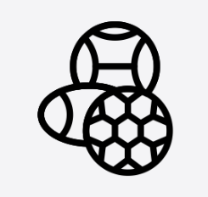 | EYFS | Year 1 | Year 2 | Year 3 | Year 4 | Year 5 | Year 6 | KS3
Control | I can stop a ball with some control. | I can stop and control a ball close to me. | I can stop, catch and strike a ball. | I can begin to control, strike, catch a ball whilst moving.  I can keep possession with some accuracy | I can control, strike, catch a ball whilst moving and keep possession with some accuracy. | I can control, catch, send and receive a ball accurately while moving and keeping to the rules. | I can control movement with a ball in an opposed situation whilst moving. | develop their technique and improve their performance in other competitive sports [for example, athletics and gymnastics]
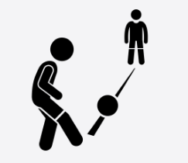Passing | I can send a ball in the direction of another person. | I can send a ball in the direction of another person and collect a ball. | I can pass a ball to someone else and receive a ball when moving. | I can accurately pass to someone else and am aware of space and how to use it. | I can develop consistency when passings to someone else and am aware of space and how to use it.  I can choose simple tactics for sending and defending. | I can pass a ball in opposed situations. | I can combine accurate passing with control and movement in a opposed situation.
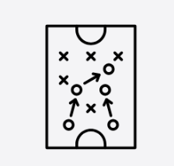  Tactics | I can often control a ball on my own. | I can take part in sending and receiving activities with a partner. | I can take part in conditioned games with opponents. | I can use my own skills to influence the conditioned games with opponents. | I am can differentiate between attacking and defending tactics | I can take part in a conditioned game with an understanding of tactics and rules and use this to help improve performance. | I can link attacking and defending tactics with accurate passing and control skills to improve performance in competitive sport. | use a range of tactics and strategies to overcome opponents in direct competition through team and individual games [for example, badminton, basketball, cricket, football, hockey, netball, rounders, rugby and tennis]
Body awareness | I can move with a ball in a space safely.  I can talk about ways to keep healthy. | I can talk about exercising safety and short term effects on exercise. | I understand about exercising being safe and the short term effects of exercise. | I can describe how my skills differ to other focusing on what we are good at.  I can talk about why it is important to warm up/cool down and lead a partner through short warm up routines. | I am aware of how I can improve based on what I am good at.  I can begin to lead others in a warm up including stretches. | I understand and can use principles of exercise activities for warming up and recognise how exercise is good for health. | I understand and can explain the short term effects of exercise, warming up and cooling down.  I understand and can explain long term effect of exercise.
Athletics   | EYFS | Year 1 | Year 2 | Year 3 | Year 4 | Year 5 | Year 6 | KS3
Running | I can move at different speeds. | I can walk, jog, run and sprint. | I can run at speed appropriate to distance. | I can choose suitable running technique depending on the distance. | I can use techniques to improve the stamina of my running. | I can improve and sustain different running technique at different speeds in a variety of athletic events. | I can refine technique which increases the speed or stamina of my run and use these techniques in different races. | develop their technique and improve their performance in other competitive sports [for example, athletics and gymnastics]
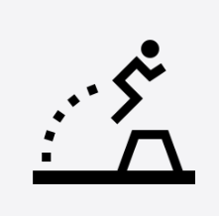Jumping | I can jump from two feet and land on two feet.  I can hop. | I can jump accurately and with good stability towards a target. | I can use good technique and dynamics to improve my jumping accuracy. | I can perform a standing long jump. | I can use good technique to improve the distance of my standing jump. | I can take a run and jump.  I can take a standing high jump. | I can refine technique which improves the distance and height of my jump.
  Throwing | I can throw a ball toward a target. | I can demonstrate an over arm and under arm throw. | I can adjust the power of my throw based on distance. | I can demonstrate a range of throwing actions using a variety of objects. | I can use throwing techniques to improve the accuracy of the throw. | I can adjust the power and technique of my throw depending on distance. | I can refine technique which improved the distance and accuracy of my throw using a variety of objects.
Body awareness | I can explain how to succeed.  I can identify when I am being active and when I am being still. | I can explain how I could improve my performance.  I can identify what physical activity I enjoy and why I enjoy it. | I can explain how I have improved.  I can give reasons why athletics is good for my health. | I can identify and explain what makes a good athletics performance. | I can identify and explain what makes a good athletics performance and make suggestions to improve.  I can recognise changes in my body when I perform athletics activities. | I can explain how to improve technique in a variety of events.  I can recognise a change in heart rate, temperature and breathing rate during exercise. | I can analyse mine and others performances and offer targeted advice.  I can identify issues which might affect mine and others’ ability to be physically active.
Orienteering   | EYFS | Year 1 | Year 2 | Year 3 | Year 4 | Year 5 | Year 6 | KS3
Map skills | To understand directions & travel forwards, backwards, left & right. | To understand that symbols in a legend represent real – world features; to interpret a simple map and transfer understanding to real world concrete materials. | To know the four cardinal directions and use these to complete outdoor challenges; to use known features on the orienteering map to navigate from the start to controls. | To be able to hold and orient a map. | To be able to consistently orient a map and use techniques to travel using a map. | To use techniques such as map memory and control flow. | To use a compass to take a bearing. | take part in outdoor and adventurous activities which present intellectual and physical challenges and be encouraged to work in a team, building on trust and developing skills to solve problems, either individually or as a group

