

Safeguarding at Plymouth Nursery Schools Federation

Ham Drive Nursery School and Day Care is committed to safeguarding and promoting the welfare of all its pupils.
If you are concerned about the wellbeing of a child or adult, please do not hesitate to speak to one of our safeguarding team.
If you feel unable to do this for any reason, please contact one of the other agencies outlined below.

Safeguarding is everybody’s responsibility!

Designated Safeguarding Lead | Deputy Designated Safeguarding Lead | Deputy Designated Safeguarding Lead | Deputy Designated Safeguarding Lead | Deputy Designated Safeguarding Lead | Safeguarding / Whistleblowing Governor
 |  | 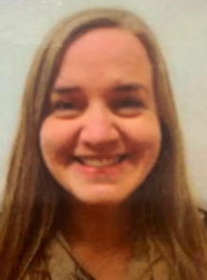 | 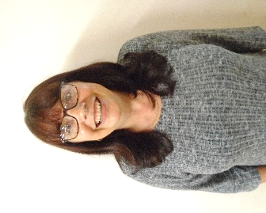 | 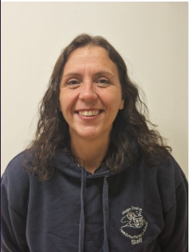 | 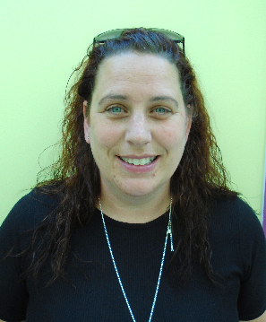
Heidi Price  Chief Executive | Caroline Watts  Head of School | Emma Forsyth  Assistant Headteacher | Toni Edwards  Day Care Manager | Kelly Jones  Room Lead – The Nest | Linsey Parker  Governor
Our Safeguarding Team

Other useful contacts:
If you are concerned about the immediate welfare of a child or adult, call 999.
Children’s Social Care - Integrated MASH & out of hours team can be contacted for advice: familiesfirst@plymouth.gov.uk or 01752 668000 +option 2
Sally Parma - Local Authority Designated Officer (LADO): 01752 306340 or email lado@plymouth.gov.uk NSPCC advice line: 0808 800 5000
Plymouth and Torbay Safeguarding Children Partnership: www.ptscp.co.uk ‘Prevent’ team: 0800 011 3764
National Anti- Terrorism hotline: 0800 789321

