
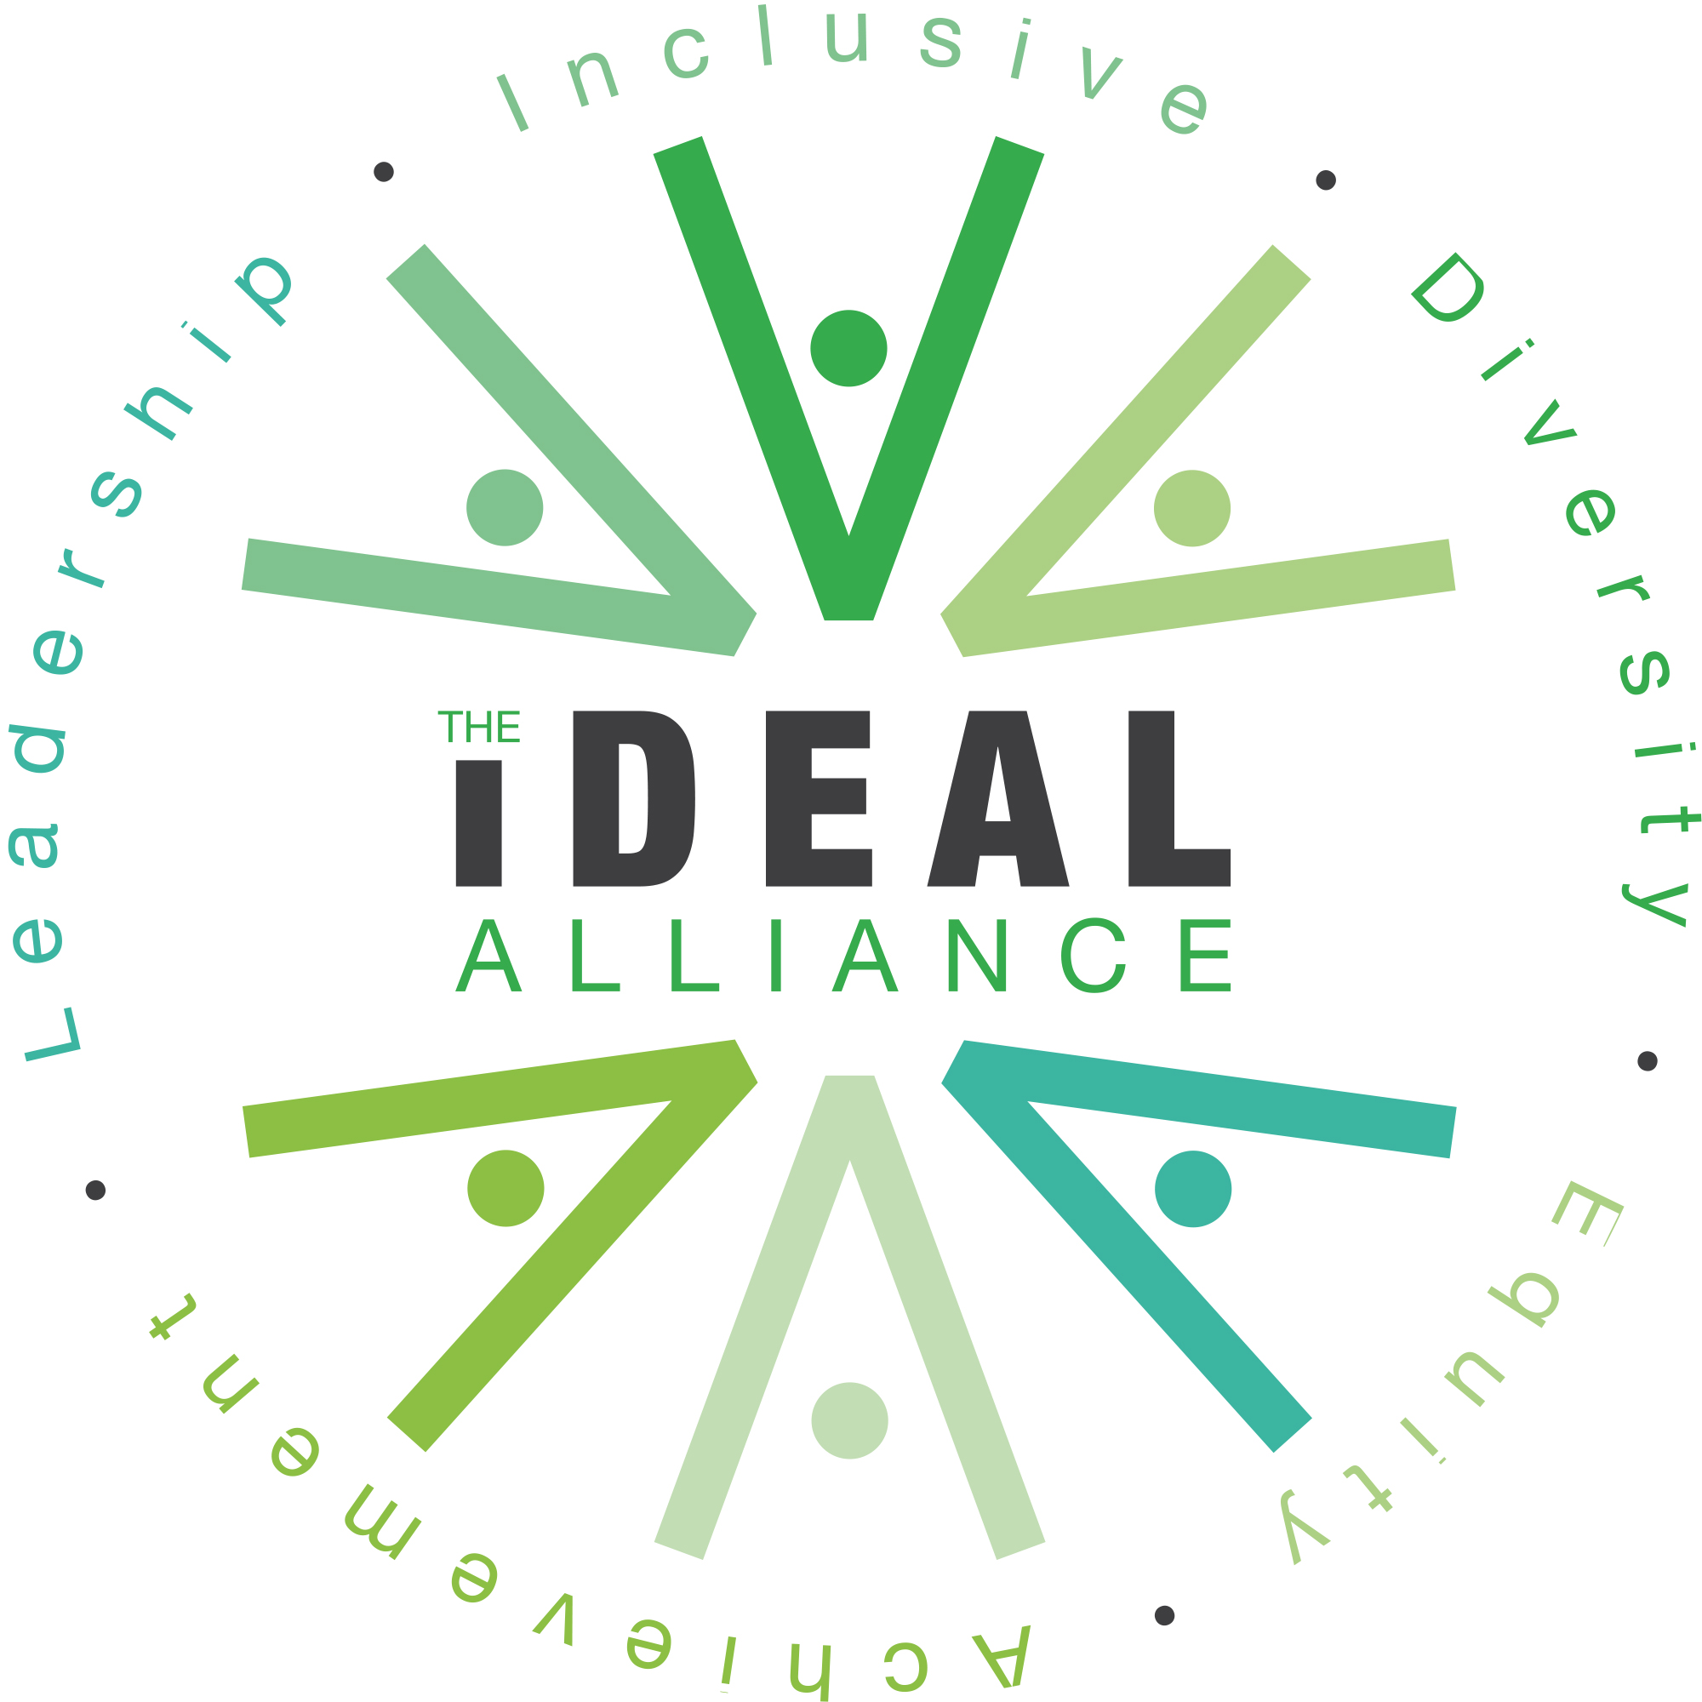


School AI Use Policy
1. Introduction and Purpose
At Yealmpstone Farm, we recognise the potential of Artificial Intelligence (AI) to enhance teaching, learning, and operational efficiency. This policy outlines how AI may be used responsibly by staff and pupils, ensuring alignment with our safeguarding duties, curriculum aims, and values of inclusion, curiosity, and integrity.
2. AI Use by Staff
Permitted Uses
Staff may use AI tools to:
- Plan and adapt lessons, including scaffolding for SEND and EAL learners.
- Generate differentiated resources, visual supports, and curriculum-linked materials.
- Support administrative tasks (e.g. drafting letters, summarising meeting notes).
- Enhance CPD through scenario-based training or professional reflection.
- Explore creative applications (e.g. story starters, quiz generation, visual prompts).
Conditions and Safeguards
- AI-generated content must be reviewed and edited before classroom use.
- Staff must not input personal data about pupils, families, or colleagues into AI tools.
- Any use of AI must comply with GDPR and school safeguarding protocols.
- Staff should avoid over-reliance on AI and maintain professional judgement.
- AI outputs must not replace teacher-led assessment, feedback, or relational pedagogy.
3. AI Use by Pupils
General Principles
AI tools may be introduced to pupils in a guided, age-appropriate way to:
- Foster digital literacy (see computing curriculum) and critical thinking.
- Support creativity (e.g. story generation, image prompts).
- Enable access (e.g. voice-to-text, translation, visual scaffolds).
Restrictions
- Pupils must only use AI tools under direct supervision.
- AI must not be used for independent research, messaging, or unsupervised writing.
- No pupil data (names, photos, identifiers) may be entered into AI platforms.
- AI use must be planned and purposeful, not recreational or filler activity.
SEND Considerations
Where appropriate, AI may be used to support access for SEND learners (e.g. symbol-supported text, simplified explanations), with staff oversight and parental awareness.
4. Data Protection and Safeguarding
- All AI use must comply with the school’s Data Protection Policy and Safeguarding Policy.
- Staff must not use AI tools that store or share data externally without explicit approval.
- Any concerns about AI-generated content must be reported to the DSL or SLT.
5. Curriculum and Pedagogy
- AI should complement, not replace, high-quality teaching and relational learning.
- Teachers remain responsible for curriculum coverage, assessment, and pupil progress.
- AI use must be inclusive, equitable, and aligned with school values.
6. Monitoring and Review
This policy will be reviewed annually by SLT and the Computing Lead, with input from staff, governors, and pupil voice. Training and updates will be provided as needed.

Approved by: | (Name)
Last reviewed on: | (Date)
Next review due by: | (Date)

