
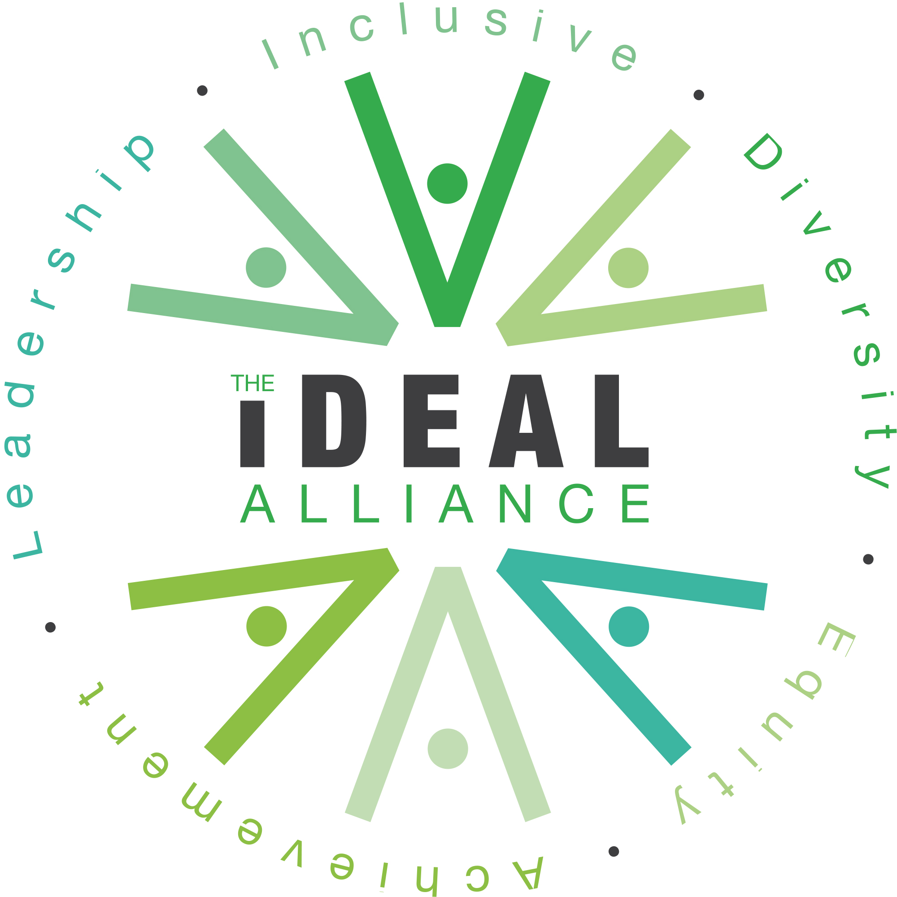
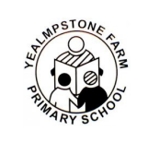

Geography Policy
1. Introduction and Purpose
Our Geography curriculum reflects our shared values of Inclusion, Diversity, Excellence, Achievement and Leadership. Through high‑quality teaching and meaningful experiences, we aim to:
- Inspire curiosity and fascination about the world, its people, and the environments we share.
- Equip pupils with secure geographical knowledge, vocabulary and skills that build progressively from EYFS to Year 6.
- Provide a child‑centred curriculum that values exploration, questioning and hands‑on learning.
- Develop pupils’ understanding of place, space, scale and environmental responsibility.
- Promote respect for diversity, cultures and global communities.
- Offer rich opportunities for fieldwork, outdoor learning and real‑world geographical enquiry.
- Prepare pupils to become informed, responsible and active global citizens.
2. Curriculum Overview
Our Geography curriculum follows the National Curriculum (2014) and is designed to be coherent, progressive and engaging. It is structured around 5 key strands:
- Locational Knowledge
- Place Knowledge
- Human Geography
- Physical Geography
- Geographical Skills and Fieldwork
Key Stage 1
In KS1, pupils develop foundational geographical understanding through:
- Learning about the United Kingdom and its countries, capital cities and surrounding seas.
- Exploring their local area and identifying key human and physical features.
- Using simple maps, aerial photographs and basic fieldwork skills.
- Comparing the UK with a contrasting non‑European country.
- Developing early geographical vocabulary such as beach, cliff, city, forest, river, weather, season.
Learning is practical, exploratory and rooted in children’s immediate experiences, encouraging them to notice, question and describe the world around them.
Key Stage 2
In KS2, pupils deepen and broaden their geographical knowledge by:
- Locating and naming counties, cities, regions and major geographical features of the UK.
- Developing a secure understanding of Europe, North and South America, and key global biomes.
- Exploring human and physical processes such as climate zones, rivers, mountains, settlements and land use.
- Using increasingly sophisticated maps, atlases, digital mapping and fieldwork techniques.
- Conducting geographical enquiries that involve collecting, analysing and presenting data.
KS2 pupils are encouraged to think critically, make connections, and understand how geographical processes shape the world.
3. Assessment and Planning
Planning is informed by the National Curriculum, school progression documents and the needs of each cohort.
- Teachers plan sequences of lessons that build knowledge cumulatively and revisit key concepts over time.
- Assessment is ongoing and formative, based on observations, discussions, written work and practical tasks.
- Summative assessments are completed at the end of each unit to track progress and identify next steps.
- Assessment is used to ensure all pupils, including those with SEND, are supported and challenged appropriately.
- The Geography Lead monitors planning, books and outcomes to ensure consistency and high standards.
4. Opportunities in Geography
Fieldwork on School Grounds and Local Area
Fieldwork is a core part of our curriculum. Pupils regularly engage in:
- Mapping the school grounds
- Weather observations
- Habitat studies
- Traffic surveys
- Local walks to explore land use, physical features and community spaces
These experiences help children apply classroom learning to real environments.
Links with Dartmoor Rangers
Our partnership with Dartmoor Rangers provides:
- Expert‑led outdoor learning sessions
- Opportunities to explore moorland habitats, tors, rivers and archaeological features
- First‑hand experiences of conservation, land management and environmental stewardship
This partnership enriches pupils’ understanding of physical geography and human impact.
Ten Tors and Outdoor Leadership
Older pupils are introduced to the geography of Dartmoor through:
- Navigation skills
- Understanding contour lines, grid references and route planning
- Developing resilience, teamwork and leadership
While not all pupils participate in Ten Tors, the skills and knowledge underpinning it are embedded in our curriculum.

Residentials Featuring Key Geographical Skills
Residential visits provide immersive geographical learning, including:
- Coastal studies
- River investigations
- Orienteering
- Human and physical geography comparisons
These experiences deepen pupils’ sense of place and broaden their geographical perspective.
5. Role of the Geography Lead
The Geography Lead plays a vital role in ensuring high‑quality provision across the school. Their responsibilities include:
- Developing and reviewing the Geography curriculum to ensure progression, coherence and alignment with IDEAL Alliance values.
- Supporting staff with planning, resources and subject knowledge.
- Monitoring teaching and learning through book looks, pupil voice, planning reviews and learning walks.
- Leading professional development and modelling effective practice.
- Ensuring fieldwork is meaningful, safe and well‑planned.
- Maintaining links with external partners such as Dartmoor Rangers and local environmental organisations.
- Celebrating geography across the school through displays, assemblies and enrichment opportunities.
- Tracking attainment and progress to ensure all pupils achieve well.

Approved by: |  | Date:
Last reviewed on: | April 2026
Next review due by: | April 2027

