

Safer Sleep Policy
1 POLICY STATEMENT
‘Sleeping children must be frequently checked to ensure that they are safe. Being safe includes ensuring that cots/bedding are in good condition and suited to the age of the child, and that infants are placed down to sleep safely in line with latest government safety guidance’ Statutory Requirements EYFS 2021 (3.60)
The Key Person meets with all parent / carers before a child’s initial first settling visit at nursery. Part of the introduction to the provision provided by PNSF is to gain knowledge of the child’s individual routine and their sleep and rest time periods. Staff will discuss and record on the initial parent appointment paperwork, the individual needs and requirements of each child to ensure their rest routine, where possible, mirrors that of home-life. This information is shared with the room lead who will ensure the whole team are informed.
Plymouth Nursery Schools Federation (PNSF) ensures that all babies and children are provided with a safer sleep environment to reduce the risk of sudden infant death syndrome (SIDS) in babies up to 12 months of age, and sudden unexpected death in childhood (SUDC) in children aged over 12 months.
Staff understand that whilst uncommon, there are some factors that can increase a baby’s risk of SIDS. These include:
- being born prematurely (before 37 weeks)
- low birthweight (less than 2.5kg or 5.5lb)
- exposure to smoking in pregnancy
- sleeping with babies and children on sofas or chairs

In line with NHS and The Lullaby Trust guidance, if a baby was born prematurely (before 37 weeks) or weighing less than 2.5kg or 5.5lb, PNSF staff follow the safer sleep advice for a year from their due date, rather than when they were born. Staff refer to NHS and The Lullaby Trust for further advice on safer sleep and premature or low birth weight babies.
2 SAFE SLEEPING GUIDANCE
2.1 All children will be frequently checked when they are sleeping. The nursery has a ‘Sleep Chart’ document for babies and young toddlers. They are monitored every 10 minutes during their sleep time. Timings for this are measured through use of a timer, set with an alarm at intervals of 10 minutes. This is signed by the member of staff at each interval check.
2.2 The Room Lead will allocate a member of staff to be responsible for the supervision of children when they are sleeping / resting.
2.3 Children must always be within sight and hearing of staff when sleeping. A baby monitor that allows children to be seen and heard at all times is used for children over 6 months of age but all children will always still be checked in person every 10 minutes. Babies under 6 months of age will always have an adult with them in the same room for every sleep.

2.4 For children that have medical conditions, certain emotional needs or sleep training programmes, the nursery will endeavour to enhance staff supervision however the parent should discuss this with the Key Person and manager / SLT.
2.5 All children’s mouths are checked before going to sleep.
2.6 Staff ensure children do not get too hot or cold. Sleep rooms are well ventilated. The recommended room temperature for babies (those aged 12 months and under) is 16 to 20˚C. Fans may be used to try to regulate temperature when the temperature may be higher during the summer months. There are thermometers in sleep rooms to ensure temperatures are monitored and this information will be used to report temperature concerns to SLT to be addressed.
2.7 All babies aged 12 months and under are placed to sleep in a cot - this includes travel cots. Children over 12 months sleep in cots, pods or on sleep mats as determined through discussion with the parent or carer as to their wishes.

2.8 Nursery staff will discourage children regularly sleeping in pushchairs and will not put a child to sleep in a car seat. If a child falls to sleep in a pushchair, they will be moved to a cot / sleep mat / pod.

2.9 Babies are placed down to sleep on their own, in the cot allocated to them and placed on their back ‘feet to foot’ (with feet at the bottom of the cot). Older children are placed down to sleep on their back in their own separate sleep space on a clear, flat, firm surface such as a cot, bed or suitable mattress on the floor. Once babies can move from their back to their front and back again by themselves, they can find their own sleeping position. However, staff will continue to place them on their back to sleep.
2.10 All sleep spaces will only contain a firm, flat, waterproof mattress. Light bedcovers may be used but these must be firmly tucked in and no higher than the baby’s shoulders, to prevent them from wriggling under the cover and covering their head as evidence suggests that babies (those aged 12 months and under) are at a higher risk of SIDS if they have their heads covered. Alternatively, a well-fitting baby sleep bag may be used to cover a baby. It is the safest option to use as it reduces the risk of blankets and sheets being kicked off and covering baby’s head. Baby sleep bags must be well fitted, to ensure the baby can’t wriggle down inside and staff must check the manufacturer recommendations before using a baby sleep bag. Staff will ensure the correct tog rating for the time of year is always used. No additional bedding will be used when using a baby sleep bag.
2.11 Cots are not placed by the radiator or window.
2.12 The gaps between the bars of the cots are less than 6.5cm (SIDS guidance).
2.13 Mattresses are regularly checked for any signs of damage and replaced as needed. Mattresses are regularly turned and aired.

2.14 Cots must not contain extra items such as toys, pillows, loose bedding, bumpers, wedges or straps.

2.15 Staff will check the sleeping children to ensure they are sleeping in a safe position and not tangled in a sheet/blanket.
2.16 The child’s breathing will be checked by placing a gentle hand on the child’s chest or putting the back of their hand near the child’s mouth to feel for breath.
2.17 Some items added to a child’s sleep space may increase the risk of SIDS and unnecessary items, such as cot bumpers and toys, can also increase the risk of accidents. Sleep comforters may be used for babies and children aged over 12 months only.
2.18 A Safer Sleep guidelines poster is displayed in each sleep room for staff to refer to when needed. (See appendix 1). More detailed guidance (Lullaby Trust) is also available for staff and a copy shared with staff at induction. (See Appendix 2).
2.19 The nursery checks that all products meet the relevant British Safety Standards (Appendix 3).
2.20 After each sleep the bedding is changed.

3 SAFE SLEEPING CHECKS
Whilst Sleeping:
3.1 Staff will check the sleeping children to ensure they are sleeping in a safe position and not tangled in a sheet/blanket.
3.2 The child’s breathing will be checked by placing a gentle hand on the child’s chest or putting the back of their hand near the child’s mouth to feel for breath.
3.3 Staff will ensure during safe sleep checks that all children are not hot or cold by feeling their chest or the back of their neck (hands and feet will usually be cooler, which is normal). If their skin feels clammy or sweaty, remove one or more layers of clothing or bedding. Staff will use their professional judgement during extreme temperatures, under the guidance of the Room Lead / Manager / SLT.

4 SETTLING SLEEPERS
4.1 The child’s sleeping routine is discussed with the parent/carers and recorded within their personal sleep routine i.e. length of sleep, position of sleep.
4.2 Comforters, muslins, dummies, soft toy where required should be provided from home and these will be stored with the child’s personal belongings.
4.3 If a child has a dummy and this should fall from their mouth during their sleep the member of staff will not put it back into the mouth unless the child wakes.
4.4 A child will be settled by a member of staff unless parent/carer requests they settle themselves in a cot.
4.5 Staff will sit with a child and pat/stroke their stomach or back or stroke side of face as requested by parent/carer.
4.6 Staff attend annual safeguarding training and appropriate methods for safe sleep are regularly reviewed.
4.7 If a child settles themselves’, a member of staff will sit close to the child to provide reassurance as required.
4.8 Where appropriate soothing music / white noise may be played.
4.9 The nursery will not allow a child to consume milk from a bottle in a cot or on a bed mat as a soother for settling to sleep.
4.10 Transition from sleeping in a cot to on a bed mat will be reviewed in line with the age and stage of the child and in agreement with their parent / carer.

5 REST TIME
5.1 Each provision has a ‘cosy corner’ area for children to have periods of rest when they require.
5.2 Most children by the time they transition to the Nursery School Room (3-5yrs) tend not to have an afternoon sleep, however if a child requires a sleep then staff will arrange for the child to either sleep in a designated area of their own play room or join the ‘sleepers’ in the Day Care provision.
5.3 Nursery staff will discuss with the parent/carer the child’s sleep / rest routine and how this falls within the nursery day. There may need some adaption to sleep times to ensure suitable staffing can accommodate individual needs and that there are safe areas to sleep
5.4 Nursery staff strive to provide as many learning opportunities as possible, therefore staff will discuss with the parent/carer the balance between rest and play time whilst attending the nursery session
6 ASSOCIATED POLICIES & PROCEDURES
Intimate Care Policy
Health and Safety Policy

7 APPROVAL AND REVIEW DETAILS
Approval, Review and Amendment History | Details
Written: 17.11.24 | Caroline Watts (Head of School)
Approved and adopted: 05.12.24  Last reviewed and updated: 24.04.26 following DfE guidance published 20.04.26  Signed: | PNSF Governing Board  Chair of Governors  Head of School
Date of next scheduled review: 20.04.28 | Notes:
Appendix 1
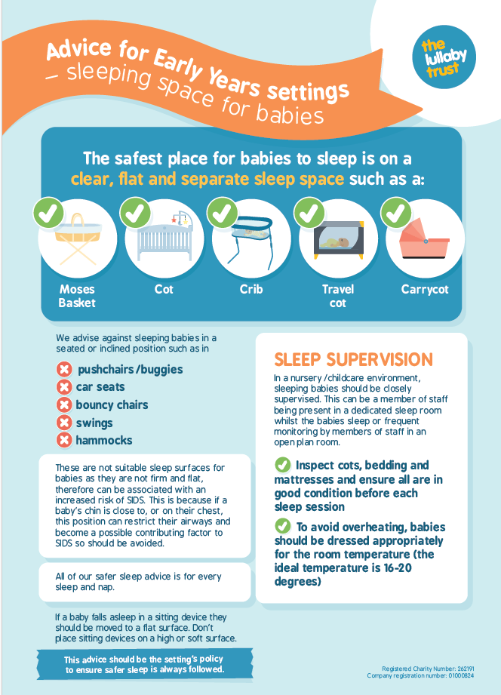

Appendix 2

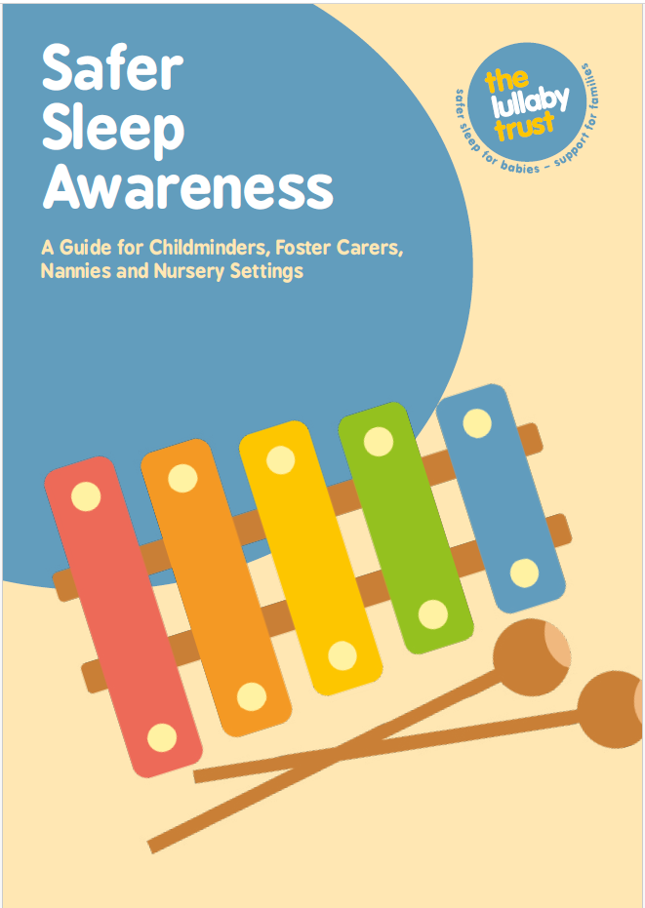
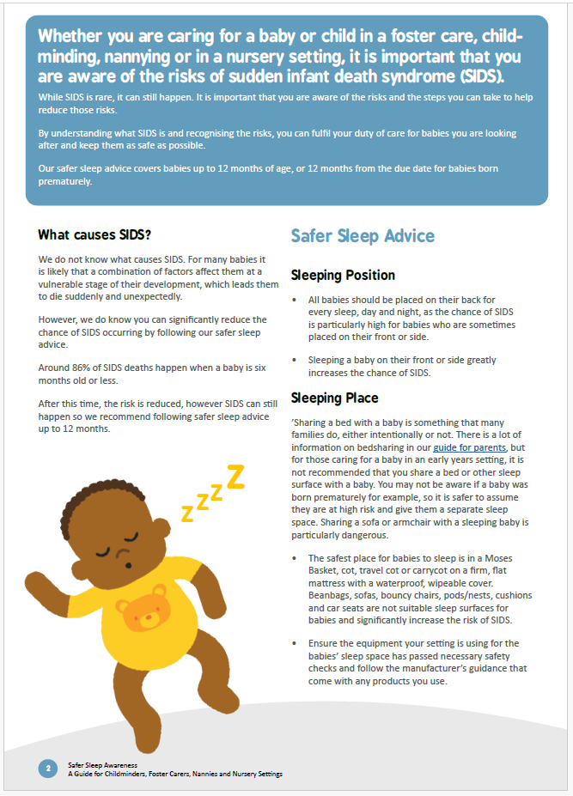
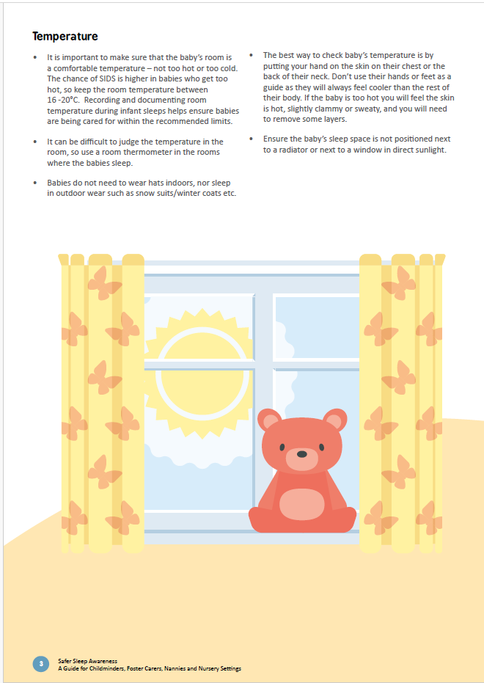
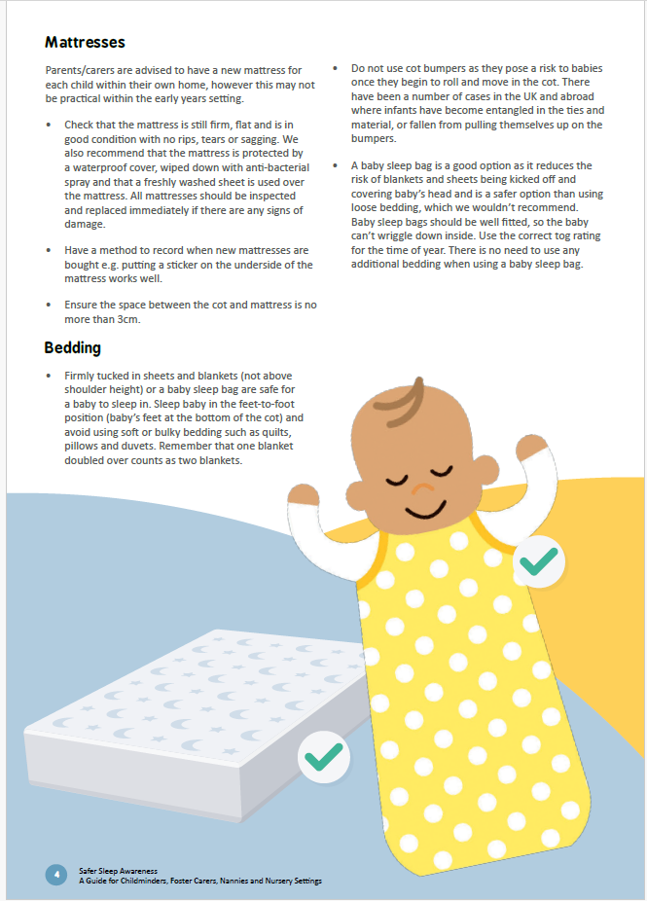
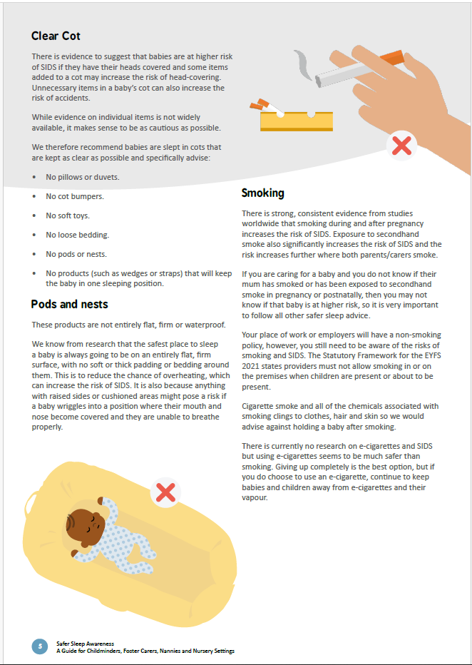
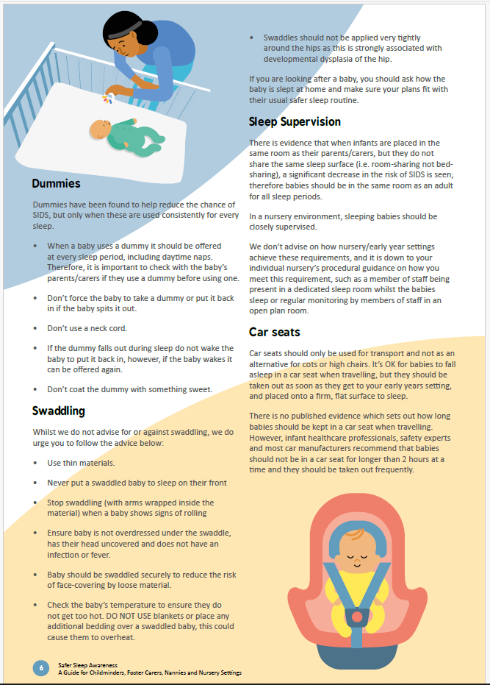
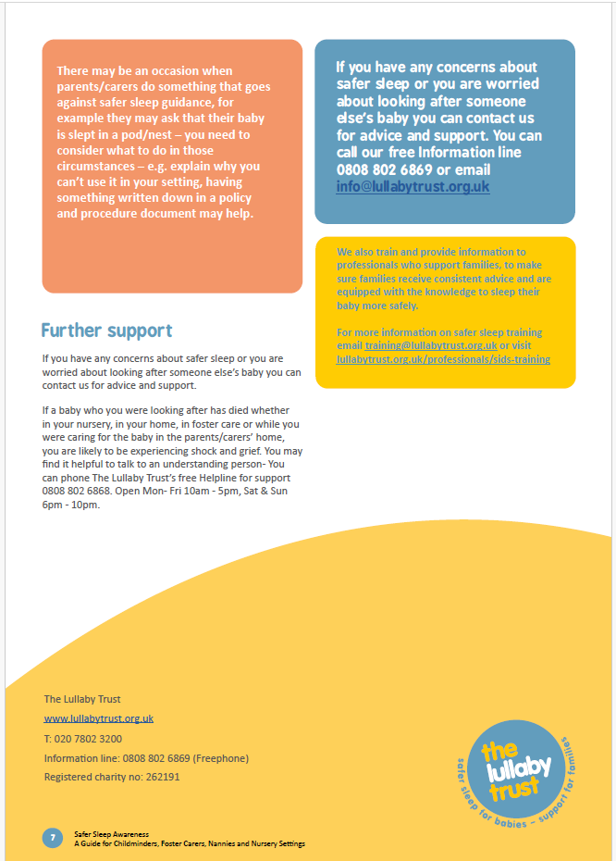

Appendix 3
All sleep products must meet the following relevant British Safety Standards:
- cots, travel cots, moses baskets and carry cots: BS EN 716-1:2017, BS EN 1466:2014 or BS EN 1466:2023
- bedside cribs: Since 2020, all bedside cribs should meet the new crib safety standard BS EN 1130:2019. This means cots should no longer have a side that fully drops down.
- mattresses: BS 7177:2008+A1:2011
- mattresses for cots, travel cots and cribs: BS EN 16890:2017+A1:2021
- sleepbags: BS EN 16781:2018

